Have You Spotted Any Hipsters in the Wild?
I don’t know what it is, but recently, it seems like we are living in the age of the Hipsters. The idea of “The Hipster” is somewhat of an older subculture, but it has been totally re-define today. “Hipsters” are basically 21st century Hippies, or at least that’s the facade they are trying to put on. Hipsters are everywhere. I was walking around Rowan University one day, and I was counting every single hipster that walked by me from class to class. I was picking them out one by one, smiling at how easy it was to spot them in a crowd. I think I counted at least twelve just in the matter of a short walking distance. Hipsters have such a distinct style from the mainstream, but the funny thing is they all end up looking like cookie cutters out of an Urban Outfitter’s catalogue because they all rock the same hair, clothes, and accessories. This is where it becomes hazy calling this group a subculture or “non-mainstream”, as they like to refer to themselves, because hipsters are exactly that: mainstreamed.
A fellow Facebook, Vaughn Thomas (October 23, 2014) states, “Hipsters are people that try extra hard to be different,” but I find this statement very hard to believe. I don’t think they’re trying to be different at all when I see twelve hipsters walk by and half of them have the same hat, shoes, glasses, or whatever else on. If they’re so “un-mainstreamed” like they claim they are, then why is it that they all look exactly alike? Most hipsters are just walking cookie cutters paying into big retail companies like Free People and Urban Outfitters, who clearly know how to market to this group of young adults being that all the members sport the same styles.
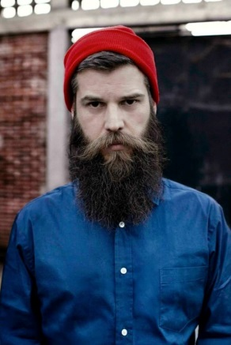
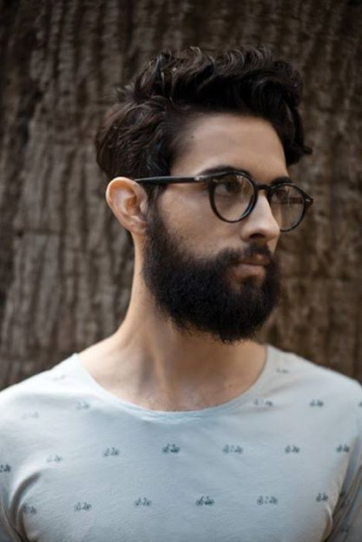
Facebook research has led me to believe that becoming a Hipster is easy. Here’s how to be a hipster in a nut shell: You have to wear pants that are incredibly too tight, preferably in a funky color like coral, burgundy or jet blue. You have to wear black-rimmed glasses (not for reading, just to wear them on your head for no purpose whatsoever.) You have to have shaggy, yet trendy hair, usually covered in a beanie or Panama hat. You have to own at least one pair of combat boots or Converse sneakers. You either have to shop at Urban Outfitters, Free People, or save a few bucks and get the same look at a local thrift store. Driving a car or taking public transportation would be ridiculous; you must ride a bicycle everywhere. A couple tattoos on the arm will also do the trick. If you’re a vegan, that just adds even more bonus points. You must love drinking coffee and hanging out in trendy spots in the city like Starbucks, or art museums, or organic restaurants. Oh, and men, you either have to have a mustache or a beard. Morwenna Ferrier, author of The End of the Hipster, suggests, “In 2014 we may have reached peak beard,” (thegaurdian.com/fashion/2014). Personally, I have never seen more beards and mustaches within a group in my life, and they’re not “normal” beards and mustaches either. Hipster beards are usually ridiculously long and un-kept, resembling the look of the earlier cave man. Their mustaches are even worse; they have the whole handlebar mustache look going on, where the mustache is wide and thick in the middle and has skinny ends that curl upwards. I don’t know why anyone would grow something like that on their face, but apparently it’s the thing to do now, from what I’m gathering through my collection of Facebook photos and posts.

I have also come to the conclusion through my findings on Facebook that hipsters are very into sharing their styles and appearances online through photos and posts (maybe this is why they are all copying one another because everyone’s ideas are laid out online for everyone to easily access). I clicked on multiple Hipster group pages, and all the posts seem to be fellow hipsters uploading photos of their latest trends and styles. In the “About” section on the Hipster’s Website (Nov. 2014) it states, “This is a place for hipsters to share and exchange fashion, beauty, style, dating, dieting and anything relating to the hipster lifestyle,” (https://www.facebook.com/HipstersCom).
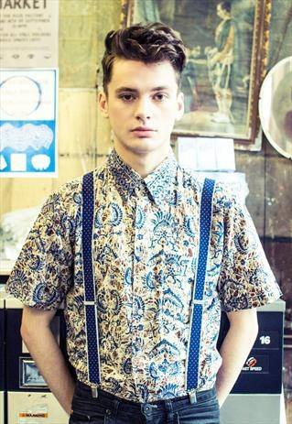

Their Group pages are basically where they can all come together and bounce ideas off of one another. Some give tips and hints on how to achieve certain styles or looks. With all this information laid out online, anyone could become a Hipster in the matter of minutes. All they would have to do is go out, buy some accessories and replicate the photos as best as possible (which is what a lot of people do in order to feel like they belong to something). I found a photo on Flickr labeled, “Hipsters Essentials” and it lists all the items a person would need in order to be part of the hipster subculture (https://www.flickr.com/photos/l-e-e/5855655774/). This includes: a tight-tee, tight pants, a Panama hat, converse sneakers, black glasses, a beard, a bicycle, and even a cigarette.
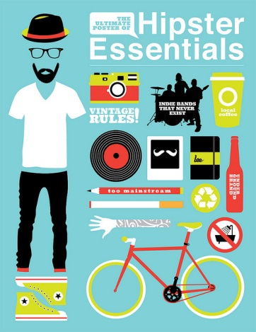

I had to laugh because the About section on the Hipster Community page states, “For the Young and Wild Non-Mainstreamer.” There goes that non-mainstream claim again, yet all the photos posted on this site were people, again, showcasing the same exact look. After scrolling through photo after photo, I swear the people started all looking alike. At times, I really had to look at the photo to tell whether it was the same person from the last photo or not. All the men in the photos seemed to be wearing the same tight, white T-shirts, with scruffy beards and Panama hats on.
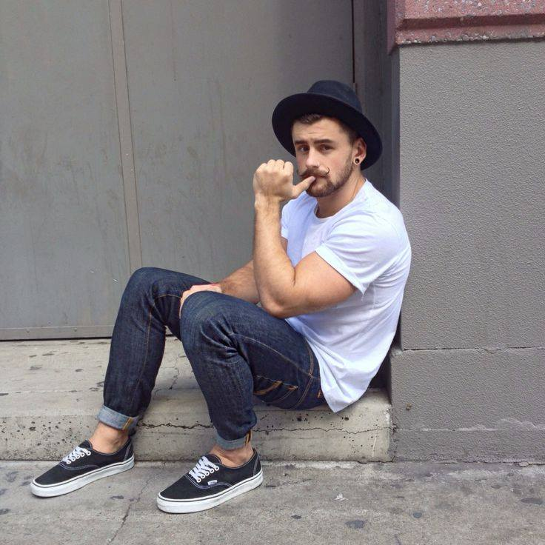
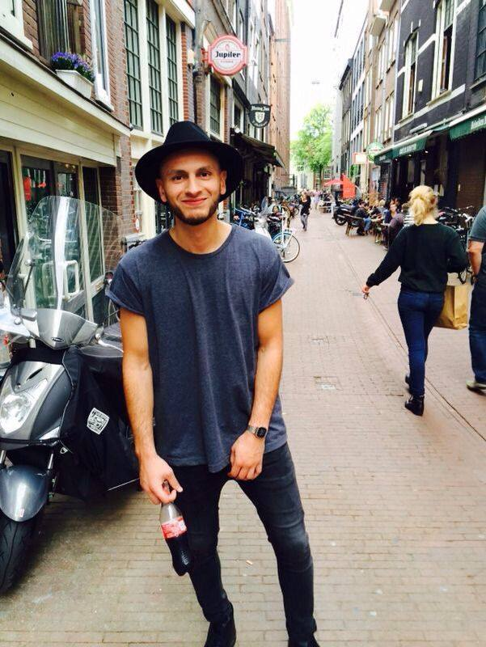

The girls were no better; they all either had red or blue hair, with a floral print skirts, combat boots and black rimmed glasses.
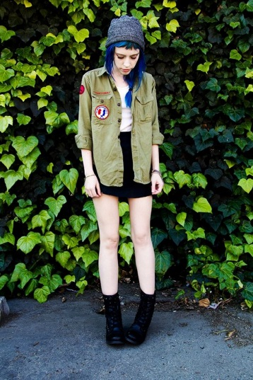
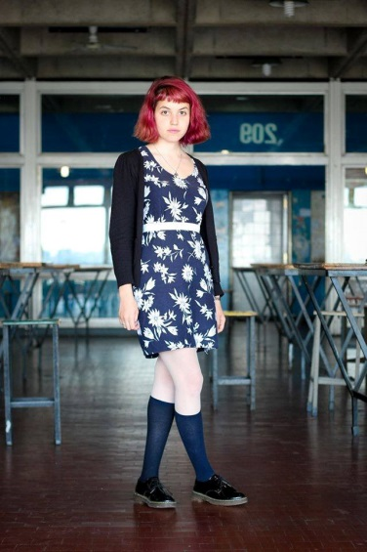

Chris Sanderson, futurologist and co-founder of trend forecasting agency The Future Laboratory, nails it right on the head by stating, "The hipster died the minute we called him a hipster” (the guardian.com/fashion). When something can be defined and pin-pointed like that, it is no longer original. When something becomes a grossly commercial parody, it is no longer non-mainstream anymore. Ferrier states, “Nowadays, anyone can appear to be a hipster provided they buy the right jeans.” If I were a true Hippie, like tye-dyed, flower-power, independent-thinking, hard-core Zepplin-lover from the start, I would be so annoyed by these little Hipsters walking around trying to replicate something they’ll never even come close to. I think that’s where a lot of the annoyance comes from. Any person can go out and buy a pair of black-rimmed glasses and combat boots and style their hair a little differently and call themselves a hipster; that doesn’t mean they’re the real deal though.
Hipsters may claim that they’re original, but being original means not being a copy or an imitation of others, and hipsters cannot truthfully say that about themselves. This subculture is nothing but a bunch of replicas, which is why this group is very irking to some people. Hipsters themselves don’t even like to be called to “Hipsters”, because they know there is a negative connotation with the term. People get very agitated with the fact that this group seriously tries to claim they are non-mainstream, when in reality, they couldn’t be more mainstreamed right now. In the end, they’ll still walk around with their fake glasses and their un-trimmed beards. They’ll prance around in their floral skirts and combat boots. They’ll listen to their indie-rock. Urban Outfitters and Free People will still stay very much in business. Everyone will be happy and merry, and I’ll just keep counting the Hipsters as they walk by.

References:

Ferrier, Morwenna. “The end of the hipster: how flat caps and beards stopped being so cool.” The Guardian. June 2014. [Assessed November 24, 2014]. http://www.theguardian.com/fashion/2014/jun/22/end-of-the-hipster-flat-caps-and-beards.

Hipster Community. “For the young and wild mainstreamer” Facebook. [Assessed November 2014. https://www.facebook.com/HipsterCommunity]

Hipster Website. “Is a place for hipsters to share and exchange fashion, beauty, style, dating, dieting and anything relating to the hipster lifestyle” [Assessed November 2014. https://www.facebook.com/HipstersCom]

Thomas, Vaughn. “So someone who tries extra hard to be different?” [Oct 24 2014. https://www.facebook.com/groups/521789527957393/].

Images:

Hipsters Group, February 2, 2013. Assessed November 24, 2014. https://www.facebook.com/HipstersCom
Hipster Community. “+150.000 #Hipsters — with Fadwa Meds and Mik'e Avicii GA.” October 23, 2014. Assessed November 24, 2014. https://www.facebook.com/hipster.cl/photos/a.325826484180070.72486.325511740878211/695861770509871/?type=1&theater
Hipster Community,“Vintage print shirt.” November 21, 2014. Assessed November 24, 2014. https://www.facebook.com/hipster.cl/photos/a.326262764136442.72632.325511740878211/710708212358560/?type=1&theater
Hipster Community, “Amsterdam #Streetstyle” November 15, 2013. Assessed November 23, 2014. https://www.facebook.com/hipster.cl/photos/a.326262764136442.72632.325511740878211/707806509315397/?type=1&theater
Hipster Community, “#style” November 13, 2014. Assessed November 2014. https://www.facebook.com/hipster.cl/photos/pb.325511740878211.-2207520000.1416839811./706774122751969/?type=3&theater
Hipster Community, “La #barba de Cristobal Palma” November 7, 2014. https://www.facebook.com/hipster.cl/photos/pb.325511740878211.-2207520000.1416840410./703784586384256/?type=3&theater

Flickr, “Hipster Essentials.” Assessed November 2014. https://www.flickr.com/photos/l-e-e/5855655774/

